Facebook Integration User Manual
Login to Facebook Account
Go through this link https://developers.facebook.com/apps/
Click on Add New App

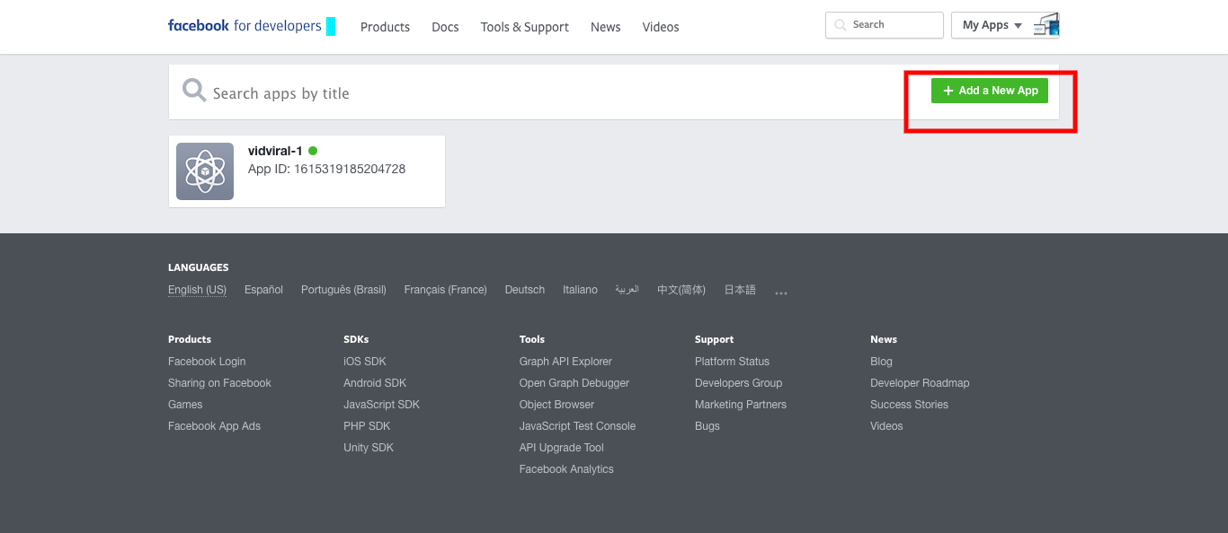

Create New App ID.
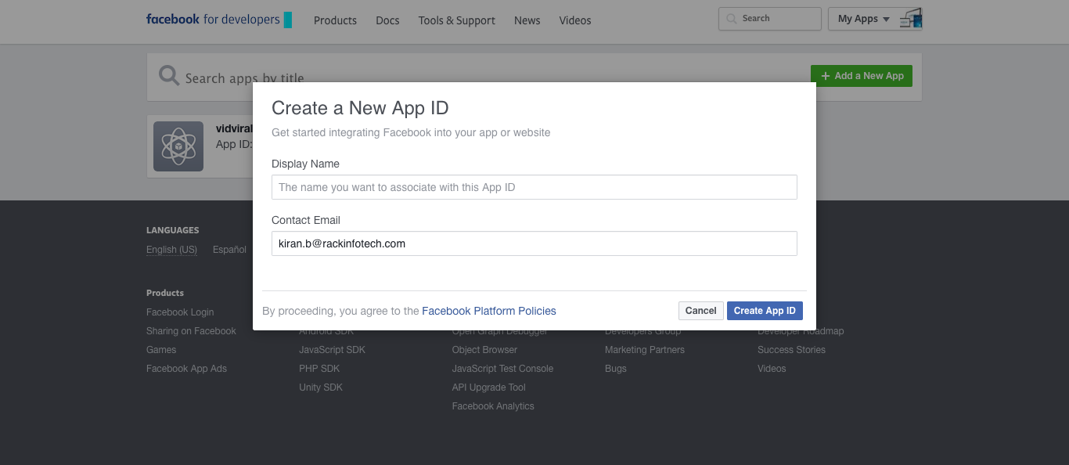

Enter display name(Name will be associate with the video which you will share on FB form VidViral) and Enter contact Email and click on Create APP Id button.

This will redirect to ADD Product page.
In Add Product, select Facebook login→ Setup→ Web
On Web Page add Site URL- VidViral and save it.
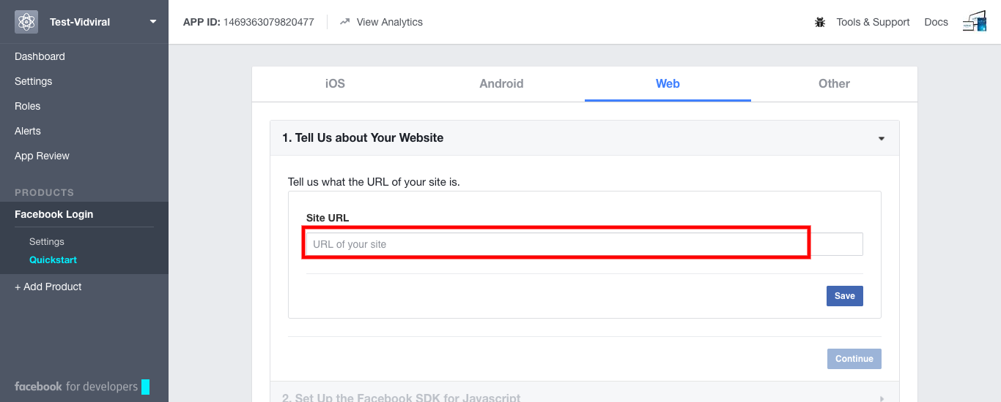

Once we saved the url. Click on Dashboard link where you will get the APP ID and APP secret key.
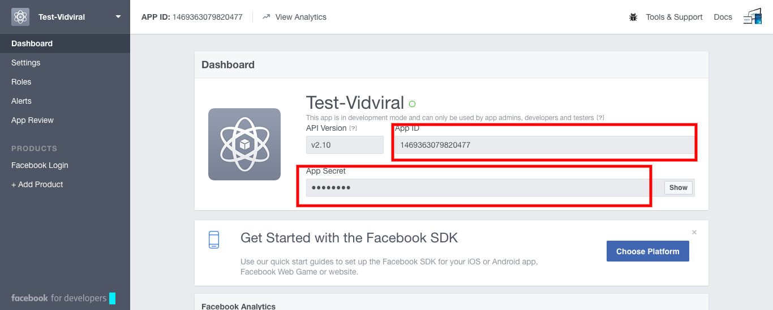

Go to Settings option
Basic: Add App domain
Select Category:Communication
Enter site URL
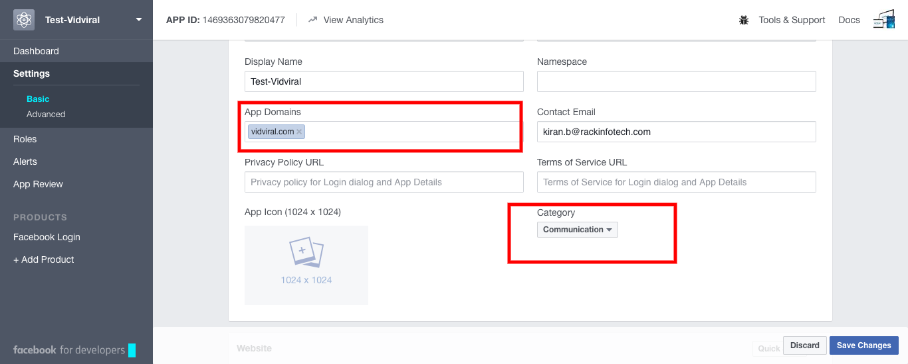
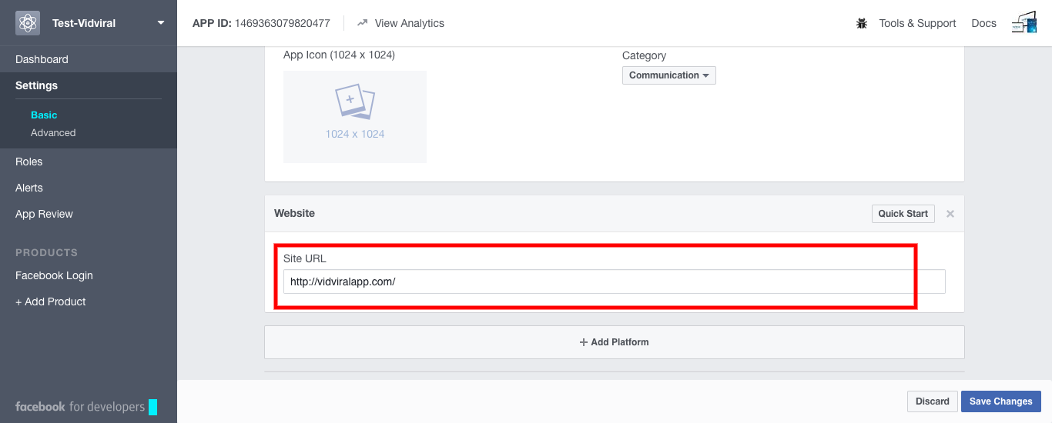
Advance: Native or desktop app: yes
Social Discovery :yes
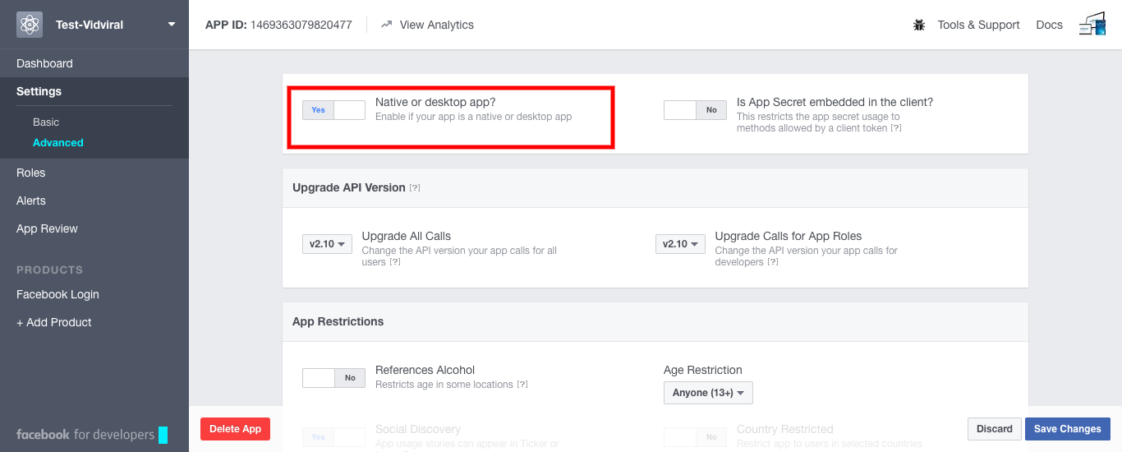
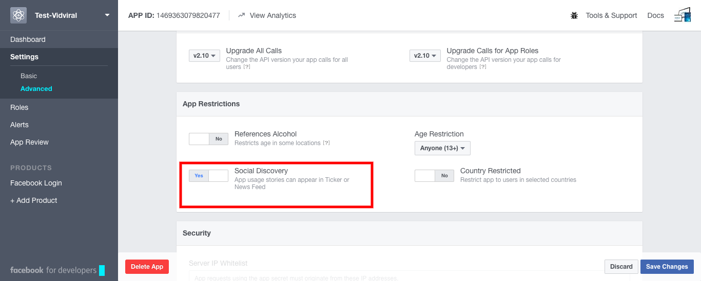

Go to App review, Make your Appname Public ? : Yes
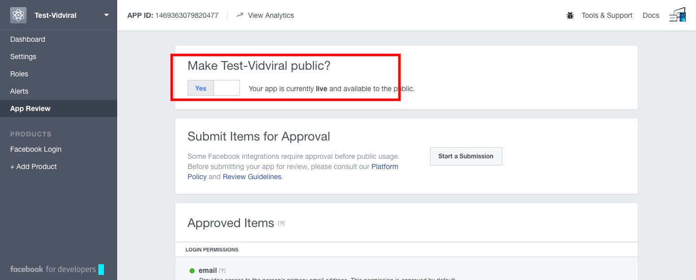

How to get Access Token:
Go to Tools and Support→ Graph API Explorer.
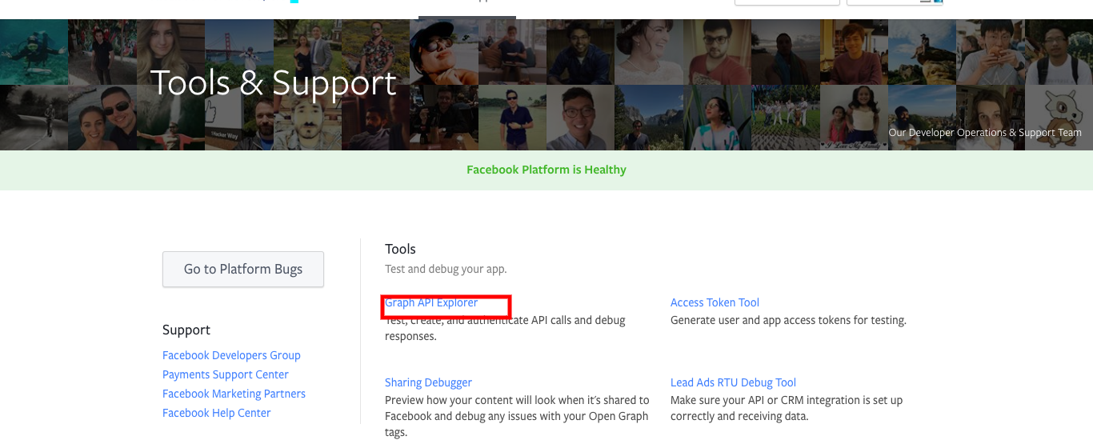
Graph Explorer page will be displayed.
Click on Graph API Explorer Dropdown.Select your app name from the list.
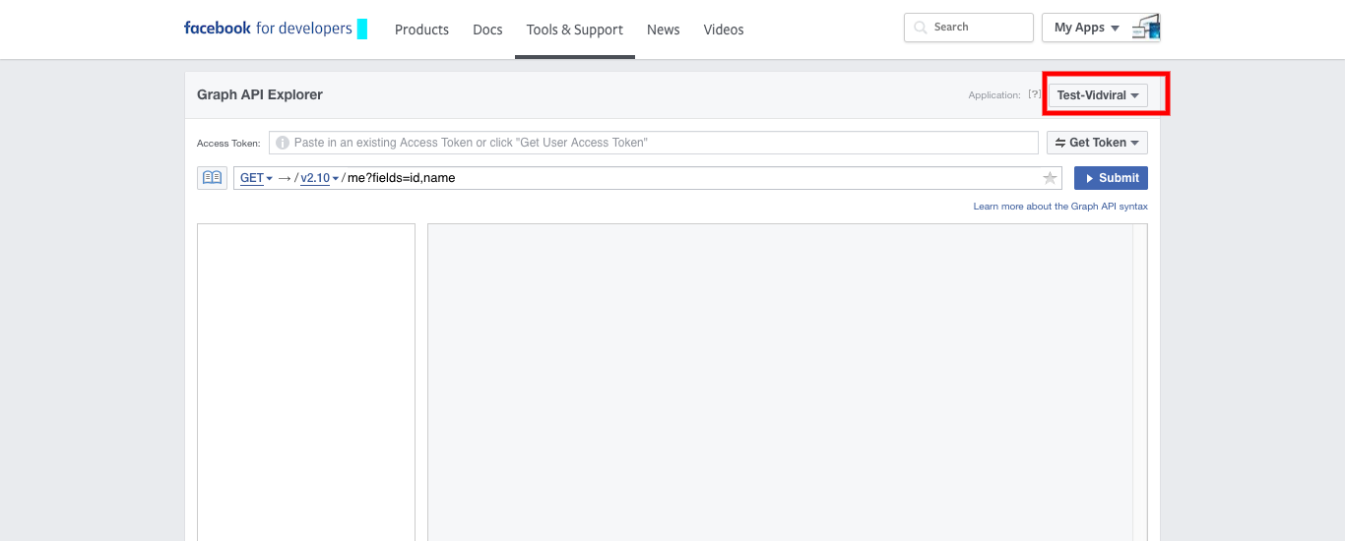

Select Get User Access Token from Get token dropdown
select following permissions from list:
Publish_actions, user_videos, user_actions.video
Click on get Access Token
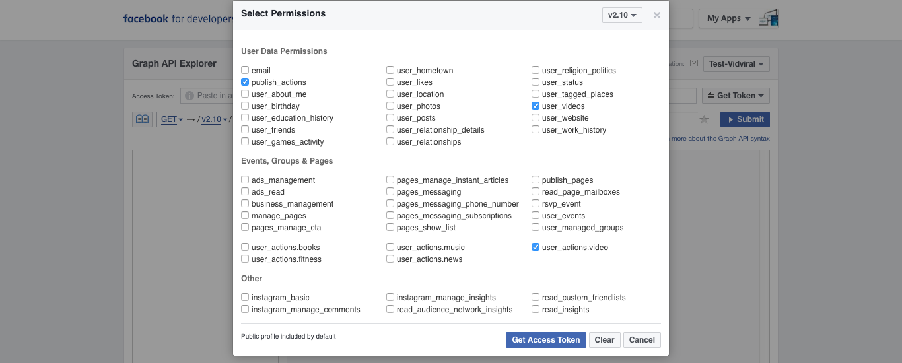

Click on Get Access Token submit button. The Facebook login popup will raise. Click on the continue button.
Then you will get the Access token.
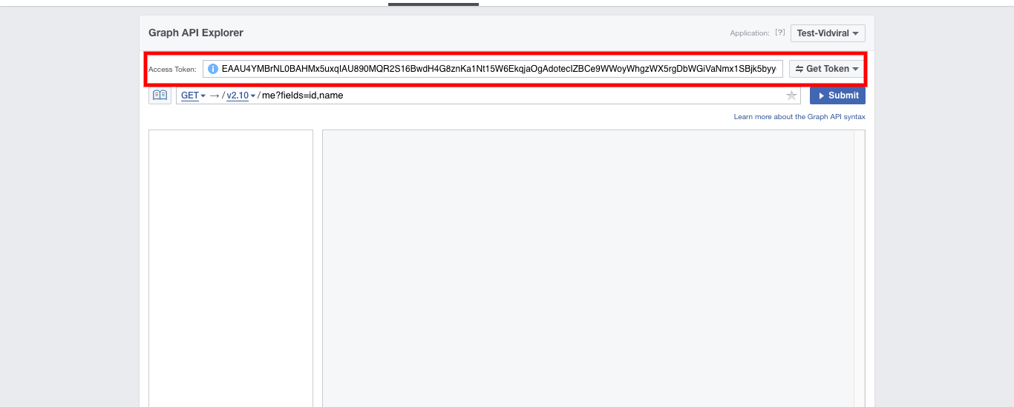

Then Enter the following details on your facebook integration page of vidviral app.
Enter App ID, App Secret , Access token.
Your facebook will get integrate with Vidiral app.

